Week 6 Lab Task
Name: Faseeha Siddiqui

Network Sniffing & WiFi Hacking
NIAI NAVTTC — Certified Ethical Hacker (CEH) Course
Task Part 1: A small business is experiencing network connectivity problems causing disruptions to their operations. Use sniffing techniques to diagnose the root cause and propose solutions.
Task Part 2: Conduct a wireless security assessment for a client's premises. Identify any unauthorized or hidden wireless networks that could pose security risks.

PART 1 — Network Sniffing (Diagnose Connectivity Issues)
▶ Set Up Your Lab Network
Make sure Kali Linux and Metasploitable 2 are running on the same Host-Only network.
Both machines should be able to ping each other before you start.
Note your Kali IP (ifconfig) and Metasploitable IP — you will need these.

Metasploitable IP: 192.168.224.101
Kali Ip: 192.168.224.102
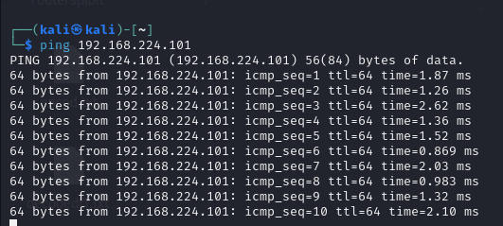
▶ Capture Traffic with Wireshark (GUI)
Open Wireshark from Kali Applications → Sniffing & Spoofing → Wireshark.
Select your network interface (usually eth0 or the Host-Only adapter).
Click the blue shark-fin Start button to begin capturing.
Generate some traffic: open a browser, ping Metasploitable, browse its web server.
Stop the capture after 1-2 minutes.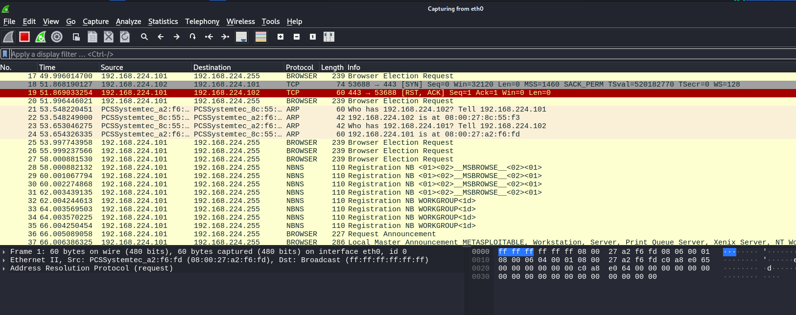

▶ Analyse the Capture in Wireshark
Use the filter bar at the top to isolate specific traffic:
http # Show only HTTP traffic
tcp # Show only TCP packets
icmp # Show only ping packets
ip.addr == 192.168.x.x # Filter by specific IP address
Look for: retransmissions (sign of packet loss), connection resets (RST flags), slow responses, or unusual protocols.
Right-click any TCP stream → Follow → TCP Stream to read full conversation.

HTTP:
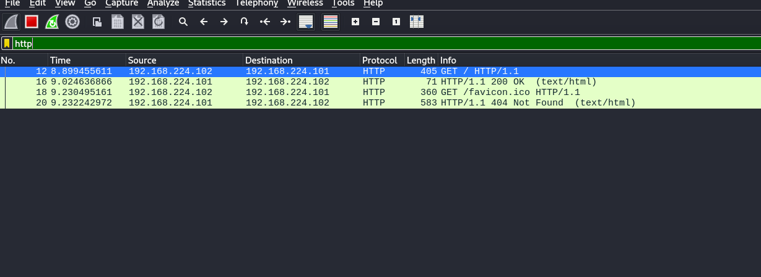
TCP:
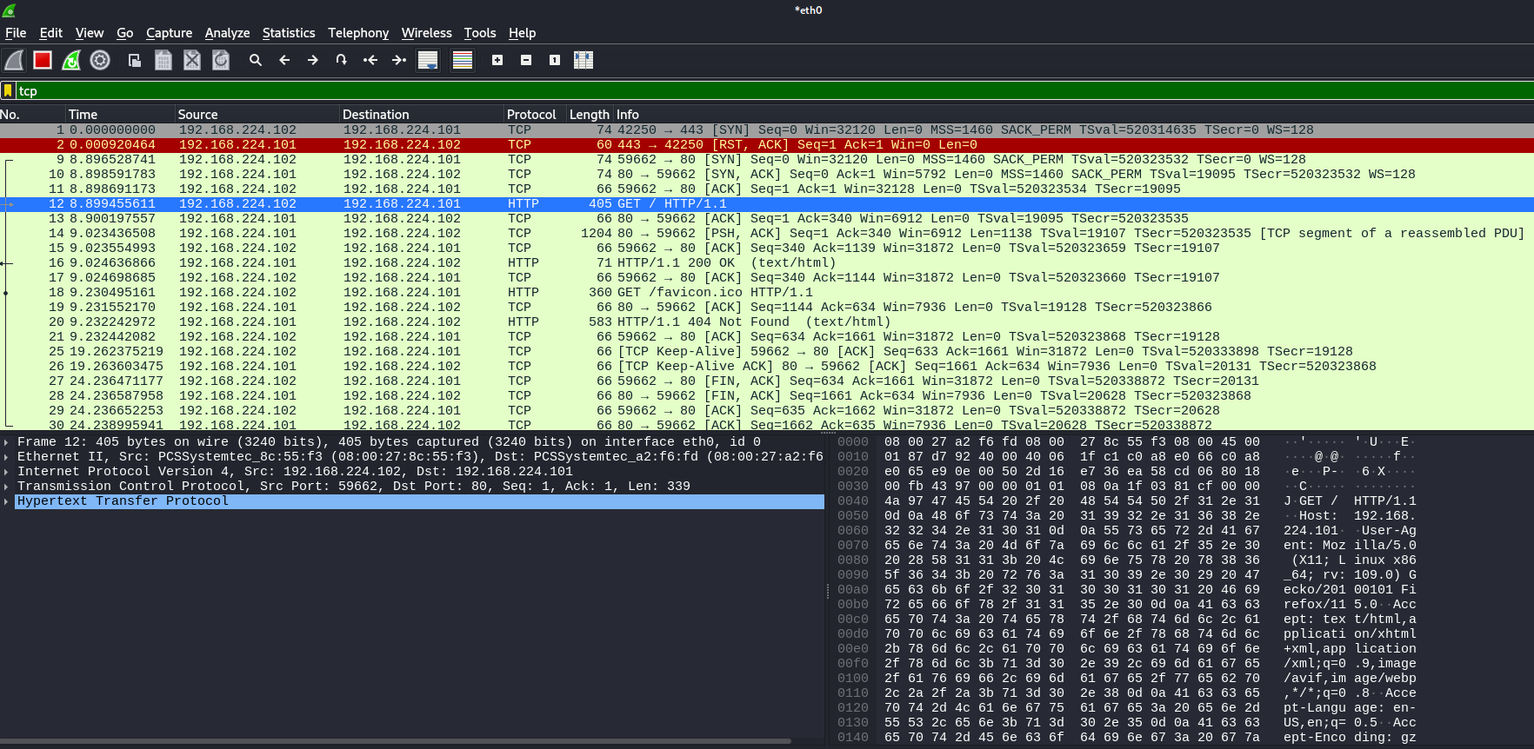
ICMP:
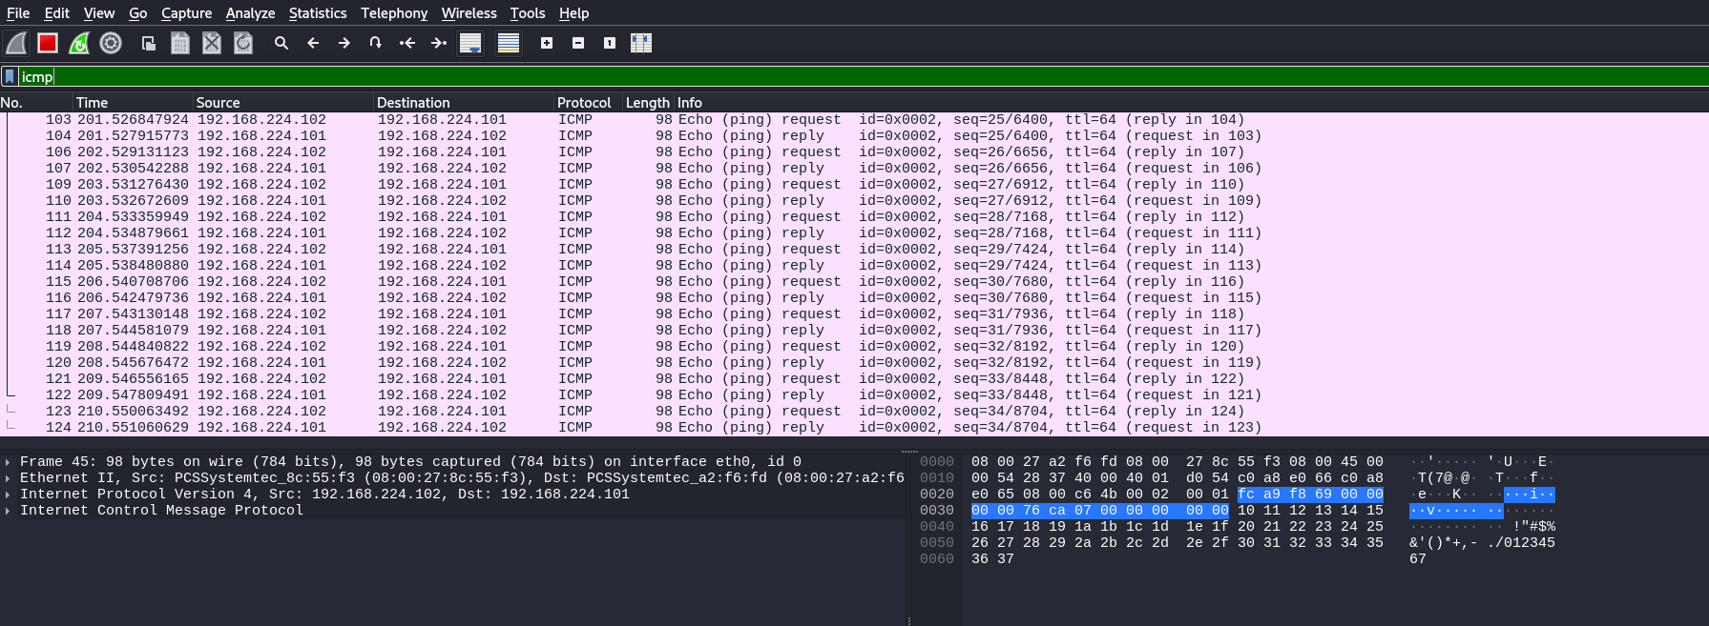

IP address search
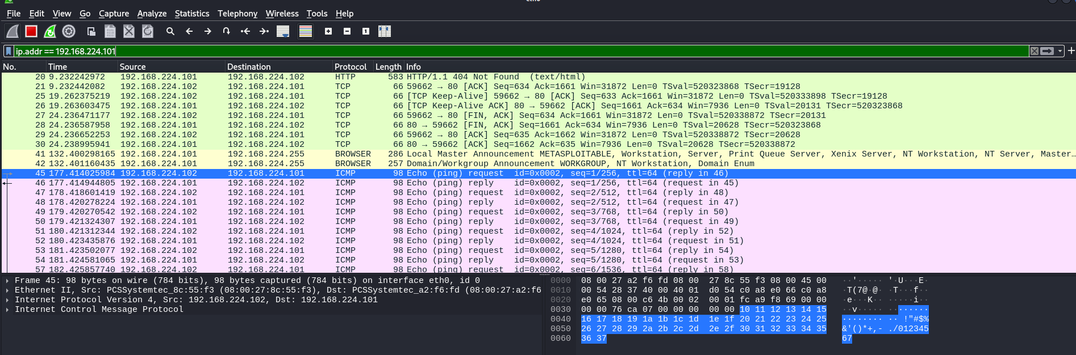

TCP Stream
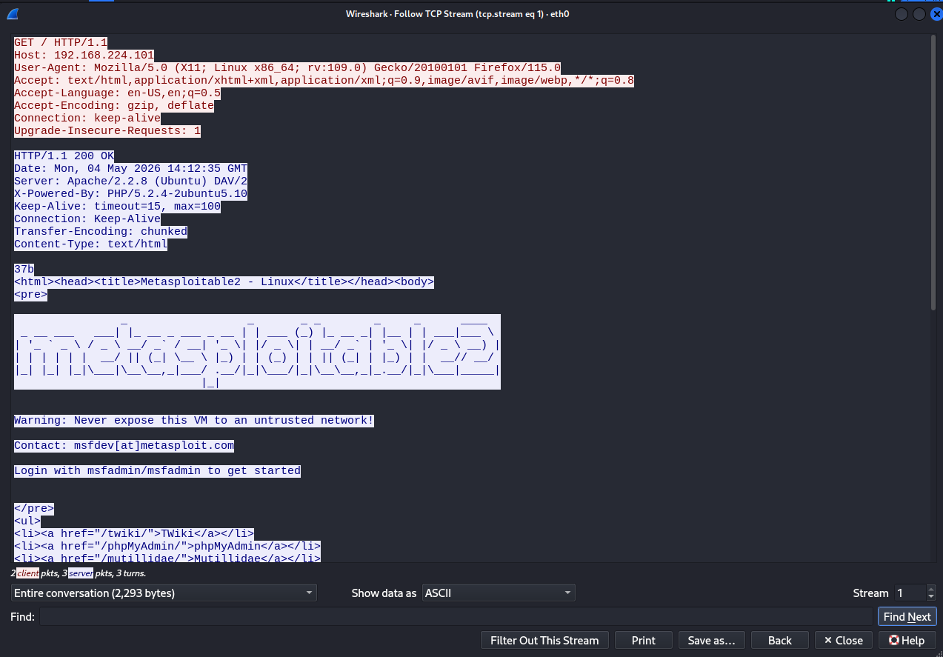
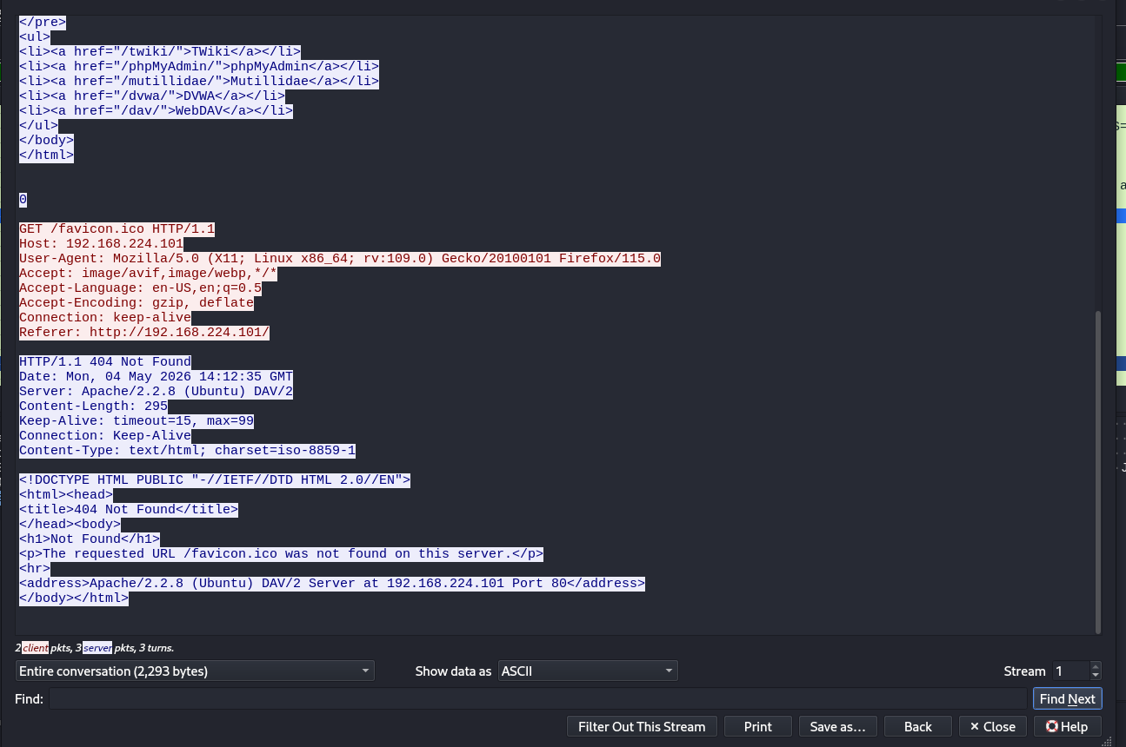

▶ Capture Traffic with tcpdump (Command Line)
Open a terminal in Kali and run:
sudo tcpdump -i eth0 # Capture all traffic
sudo tcpdump -i eth0 -w capture.pcap # Save to file
sudo tcpdump -i eth0 host 192.168.56.101 # Filter by host
sudo tcpdump -i eth0 port 80 # Filter by port
wireshark capture.pcap # Open saved capture in Wireshark
Now capture traffic in Wireshark while the MitM is active. You will see both sides of the conversation.
When done, stop arpspoof and reset ip_forward to 0.
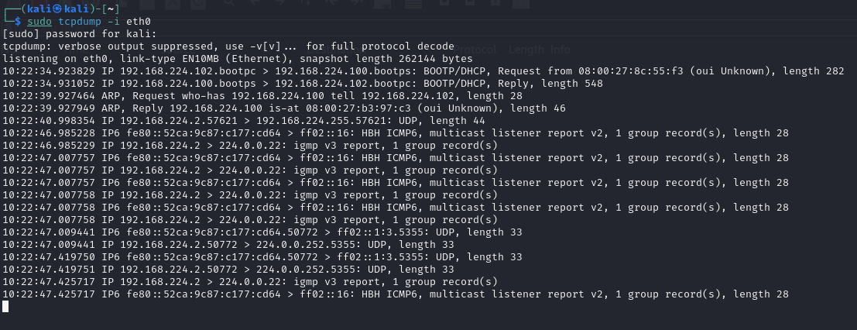
▶ Diagnose & Document Findings
Based on your packet capture, write a diagnosis report:

- What protocols were seen on the network?
The following protocols were observed in the Wireshark capture:
- HTTP → Web communication with the Metasploitable server
- TCP → Transport layer protocol managing connections
- ICMP → Ping requests and replies between hosts
- ARP → Resolving IP addresses to MAC addresses
- NBNS / BROWSER → Network discovery and workgroup announcements

- Were any credentials or sensitive data visible in plaintext?
- Yes, HTTP traffic was visible in plaintext.
- The full HTTP request and response could be read using “Follow TCP Stream”.
- Exposed information included:
- Webpage content (HTML)
- Server details (Apache version, PHP version)
- No usernames or passwords were captured in this specific traffic, but:
- Since HTTP is unencrypted, any login credentials would be exposed if transmitted.

- What is the likely root cause of the connectivity problem?
- No major network issues were detected:
  - ICMP replies were consistent → no packet loss
  - TCP connections completed successfully
  - No retransmissions or reset (RST) packets observed
Therefore, the likely conclusion is:
The network itself is stable and the problem is likely due to:
  - Server-side performance issues
  - Application-level delays
  - Misconfiguration rather than actual connectivity failure

- What solutions do you recommend? (e.g. use HTTPS, switch to SSH, fix DNS config)
1) Security Improvements
- Use HTTPS instead of HTTP to encrypt data
- Disable unnecessary services and ports
- Hide server version information

2) System Improvements
- Update outdated software:
  - Apache server
  - PHP version
- Apply security patches

3) Network Improvements
- Monitor traffic regularly using tools like Wireshark
- Reduce unnecessary broadcast traffic
- Ensure proper network configuration

4) Protocol Improvements
- Replace insecure protocols:
  - HTTP → HTTPS
  - Telnet → SSH

